AUTONOMOUS CAR RACING WITH DEEP REINFORCEMENT LEARNING
An abstract
Simple autonomous driving is a useful application of reinforcement learning. In our project, we will focus on autonomously navigating a race track. Potential actions include accelerating, breaking, and turning left and right. Rewards are granted based on proximity to the finish line. Our approach will involve benchmarking D-DQN (Double Deep Q-Network) with PPO (Proximity Policy Optimization) and SAC (Soft Actor Critic).
Keywords: DDQN, PPO, SAC, autonomous driving, gym, reinforcement learning, stable-baselines3

An introduction, describing the problem, the motivation for it, and a brief summary of your approach.
Reinforcement learning is naturally applied to autonomous driving, wherein the agent has to learn from trial and error rather than using hand‑crafted rules to control a car. In this project, the focus is on the CarRacing‑v3 environment available in Gymnasium: a 2D, top‑down racing game wherein the agent sees 96×96 pixel observations and must control steering, gas, and brake to stay on a randomly generated track and cover as many tiles as possible. This is an interesting setup since the observations are high‑dimensional images and the actions are continuous, and small mistakes in control can result in the car going off the road very fast. Besides this 2D setup, we also experimented with a 3D Gymnasium‑compatible racing environment; however, we found it harder to run reliably on our available hardware and tooling; thus, our main results and analysis will be focused on the more stable 2D environment implemented using Stable‑Baselines3.

The idea here is to see how three popular RL algorithms address this problem, namely, Double Deep Q‑Network, Proximal Policy Optimization, and Soft Actor‑Critic. DDQN represents the value‑based, discrete‑action approach where the continuous control problem is approximated by a small set of discrete driving actions. PPO is an on‑policy policy‑gradient method that updates the policy in small, stable steps and works well with convolutional policies on stacked frames. SAC is an off‑policy actor‑critic algorithm that directly handles continuous actions and promotes exploration with maximum reward and policy entropy.

Using the 2D CarRacing‑v3 environment as a common benchmark, this project compares these three methods in terms of learning speed, final performance, and driving behavior. All the agents learn from pixel inputs using CNN-based models, which are trained for several hundred thousand to one million timesteps. At the end, the comparison highlights when a discretized value-based method like DDQN is enough, when PPO's stable updates are helpful, and how SAC's entropy-driven exploration behaves on a pixel-based continuous control task.

We considered two environments– a built-in 2D and a 3D external environment:
The 2D car racing environment is part of the Box2D environments. It’s a top-down racing environment, with a random track in every episode. In continuous, there are three actions, and in discrete there are five actions. The observation has a top-down 96x96 RGB image of the car and race track.
https://gymnasium.farama.org/environments/box2d/car_racing
The 3D car racing environment uses Pybullet to simulate real-world physics. It includes observations such as pose, velocity, and rgb-camera, which are obtained by sensors. Similar to the 2D environment, it also has three actions in the continuous space. Vehicle and track configuration are customizable and multi-agent racing is possible with PettingZoo API.
https://github.com/axelbr/racecar_gym/
A brief survey of related work and background material on your project. This related work must include at least 5 conference or journal papers outside of the class readings
Güçkıran and Bolat [1] focused on how to teach a virtual race car to drive fast and safely by means of deep reinforcement learning within the TORCS simulator. Instead of programming fixed driving rules, the authors let an AI agent learn by trial and error: it receives sensor inputs, for instance, its angle to the track, distance to the track edges, and speed, and then decides how much to steer, accelerate, or brake. Compared are two approaches: a continuous-control method called Soft Actor-Critic, or SAC, which can pick any value for steering and throttle, and a discrete-action method called Rainbow DQN, which must choose from a limited set of pre-defined actions. Besides, racing tasks provide specific problems– the car might "wiggle" on straight sections or almost never apply brakes because slowing down yields lower immediate rewards-and in order to cope with those, the reward function should be designed with the utmost care to foster smooth, fast, and safe driving, introducing the "Try-Brake" mechanism that from time to time pushes the agent to use brakes so that it can learn that slowing down before curves may improve long-term performance. They train on many different tracks to help the agent generalize rather than memorize a single circuit. Their results show that the model SAC with an LSTM layer learns more efficiently and drives more smoothly and quickly than Rainbow DQN, therefore continuous-control reinforcement learning seems more suitable for autonomous car racing and can perhaps be a useful step toward more advanced autonomous driving systems.
Multiple researchers trained their model based on DQN or DDQN for their race car. Yuwono, F. et al. [3] highlighted advantages of DQN which include handling large state space with images. The online network learns from the target network in a stable way. The experience replay buffer helps reduce the correlation between consecutive samples. The researchers found that DQN performed well in the CarRacing environment as it has a robust foundation. They also implemented PPO and found that it had promising results especially with fine control over continuous action space. Li [4] implemented DDQN with CNN for the images. They used CNN to extract image features. The researcher found that in every episode, the model is always performing exploration, which is why it can have low rewards during training, but with further training it can get better.
Maniyar and Manoj [5] taught a small virtual car to drive itself around random racetracks in a game environment. The car sees only camera images from above and must learn when to turn, speed up, or brake to stay on the gray road and avoid going onto the green grass. The authors used a deep reinforcement learning method called Double Q-learning with a convolutional neural network so the agent can learn good actions from many past game experiences. They try several model designs and action choices and find that a larger CNN and a richer set of actions help the agent learn faster and reach higher predicted scores, though one model drives more naturally while another is safer but slow. In the end, the car did not perfectly finish whole tracks but reached roughly “beginner human” skill, and the authors suggested that more training time and stronger methods could make the car much better in the future.
Petrazzini and Antonelo [2] compared Gaussian and beta distribution stochastic policy distributions when applied to the v-0 CarRacing environment. They found that agents which use PPO along with beta distribution converged faster and were more stable. The average beta reward was also fifteen points higher than the Gaussian reward.
A description of your technical approach, using proper mathematical notation and formatting.
DDQN
Double Deep Q-Learning, or DDQN, involves an online network for action selection, target network for value estimation, and a replay buffer. Having both networks ensures that action selection is decoupled from value estimation. The following are the equations from DDQN.
Online Network:
$$Q_{\phi_A}(s,a) \leftarrow r + \gamma \, Q_{\phi_B}\!\left(s',\, \arg\max_{a'} Q_{\phi_A}(s',a')\right)$$
Target Network:
$$Q_{\phi_B}(s,a) \leftarrow r + \gamma \, Q_{\phi_A}\!\left(s',\, \arg\max_{a'} Q_{\phi_B}(s',a')\right)$$
Loss function:
$$I = \left( r + \gamma \, Q\!\left( s',\, \arg\max_{a'} Q(s', a', \mathbf{w}),\, \mathbf{\bar w} \right) - Q(s, a, \mathbf{w}) \right)^2$$
PPO
Proximal Policy Optimization (PPO) is a policy gradient algorithm that improves upon trust region policy optimization (TRPO). Since PPO uses first-order optimizations, it is less computationally expensive. PPO is also better at handling more complex architectures which include added noise or parameter sharing. PPO introduces a clipped objective that restricts updates over the old policy, increasing stability.
L^{\text{CLIP}}(\theta) = \mathbb{E}_t\left[\min\left(r_t(\theta) A_t,\,\operatorname{clip}\big(r_t(\theta),\, 1 - \epsilon,\, 1 + \epsilon\big) A_t\right)\right]
Where r(\theta) = \frac{\pi_{\theta}(a \mid s)}{\pi_{\theta_{\text{old}}}(a \mid s)}

SAC
SAC is an advanced, off-policy, model-free deep reinforcement learning algorithm that set the new gold standard for solving complicated continuous control problems. The main distinctive factor of SAC is that it incorporates maximum entropy reinforcement learning into an actor-critic framework, which fundamentally modifies how agents approach the exploration-exploitation trade-off. While most standard RL methods simply try to maximize the expected rewards, SAC encourages them to maximize both the expected reward and the entropy of their policy-meaning that the agent has an incentive to succeed at the task while behaving as randomly as possible.
Mathematical formulas:
\subsubsection*{SAC Objective}
The SAC objective is to maximize the expected sum of rewards plus an entropy bonus:
\begin{equation}
J(\pi) = \sum_{t} \mathbb{E}_{(s_t, a_t) \sim \rho_{\pi}}
\left[ r(s_t, a_t) + \alpha \, H\big(\pi(\cdot \mid s_t)\big) \right],
\end{equation}
where
\begin{equation}
H\big(\pi(\cdot \mid s_t)\big) = - \mathbb{E}_{a_t \sim \pi} \left[ \log \pi(a_t \mid s_t) \right]
\end{equation}
is the entropy of the policy at state $s_t$, and $\alpha$ is the temperature parameter that controls the weight of the entropy term.
\subsubsection*{Soft Bellman Backup}
The critic update uses the ``soft'' Bellman backup:
\begin{equation}
Q_{\text{target}}(s_t, a_t)
= r(s_t, a_t) + \gamma \, \mathbb{E}_{s_{t+1} \sim p} \left[ V(s_{t+1}) \right],
\end{equation}
with
\begin{equation}
V(s_{t+1})
= \mathbb{E}_{a_{t+1} \sim \pi}
\left[ Q(s_{t+1}, a_{t+1}) - \alpha \log \pi(a_{t+1} \mid s_{t+1}) \right].
\end{equation}
Your experimental methodology, the results you found (formatted as either tables or plots with proper labels and captions), and a discussion of your results. If you did a theoretical project, you should have an expanded technical approach instead of this section. If you have a survey project, you may present your critique here.
DDQN
We implemented DDQN instead of DQN. Standard DQN tends to overestimate Q-values due to using the same network for both action selection and action evaluation. This leads to unstable learning in environments with high-variance rewards and rich visual observations— both of which characterize CarRacing-v3. To mitigate this, we implemented Double DQN, which introduces a second, slowly updated “target” network to decouple action selection from action evaluation.

We enabled the built-in discrete action mode, where the environment internally maps a small set of discrete actions (e.g., steer left, steer right, accelerate, brake) to their continuous counterparts. This modification preserves the continuous physics dynamics of CarRacing while making the action space compatible with the DDQN architecture, which estimates Q-values for a finite set of actions.

We override the training from the DQN class to include a replay buffer, an online network and a target network, current Q-value estimate, Huber loss, and a target network update. A Convolutional Neural Network (CNN) policy was used to process the raw 96×96×3 96×96×3 RGB frames from CarRacing-v3. This architecture is appropriate for visual control tasks and is provided through Stable-Baselines3’s CnnPolicy. The fully connected branches of the network used: 2 hidden layers of size 256 units each, ReLU activation, and Adam optimizer with a learning rate of 10⁻⁴.

The hyperparameters were: gamma = 0.99, buffer_size = 100,000, batch_size = 32, learning_starts = 10,000, exploration_fraction = 0.2, exploration_final_eps = 0.07, train_freq = 16, gradient_steps = 8. This training schedule performs eight gradient updates every 16 environment steps, providing a balance between sample efficiency and computational load. We show the results in the following experiments of 25k, 1 million, and 600k time steps.

Time Steps: 25k

At 25,000 time steps, the following were the rewards per timestep. Over 10 episodes, the mean reward was -5.90 ± 38.16. The mean episode reward fluctuated between -130 and +20. There is high variance in the rewards, and there are occasional spikes. The model has not started meaningful learning.

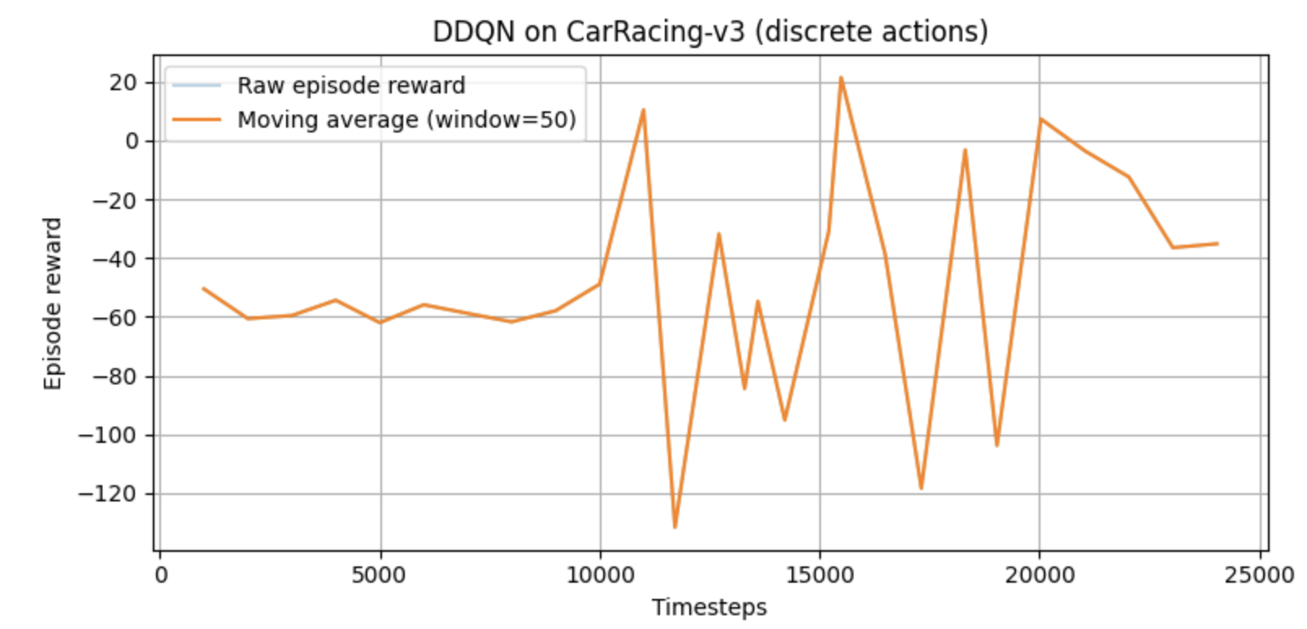
Fig. 1: Episode rewards across 25,000 time steps
At 25,000 time steps, the following were the returns for each episode. Many episodes had negative returns. None of the episodes showed stable driving. The car was mostly at an exploratory stage and hadn’t experienced high rewards. The model underfit with erroneous behavior.

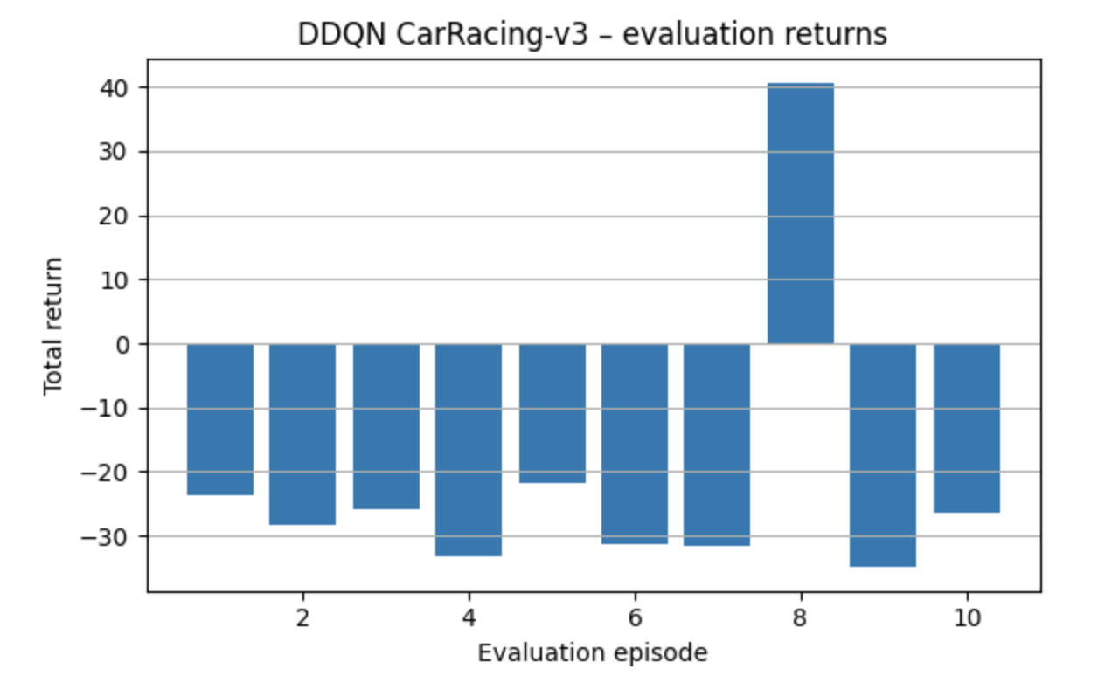
Fig. 2: Total returns in each episode across 25,000 time steps
The following video shows how the racecar drives when trained at 25,000 steps:
https://drive.google.com/file/d/1kfpV--ZYeYxQdBuRpKaQmhY8Oi9bbZBO/view?usp=drive_link

Time Steps: 1 Million

At 1 million time steps, the following were the rewards per timestep. We can see that the model converges somewhere between 600k - 700k time steps. In the first 300k steps, the rewards are near 0 or are negative. Around 300k - 450k time steps, the agent learns important driving techniques, such as maintaining speed, staying on the track, steering, not lingering in the grass (off-track). At around 450k - 650k, the agent had the highest stability, and the moving average reward peaks. At 650k timesteps and greater, the mean reward slowly decreases, variance increases, and the training becomes noisier. 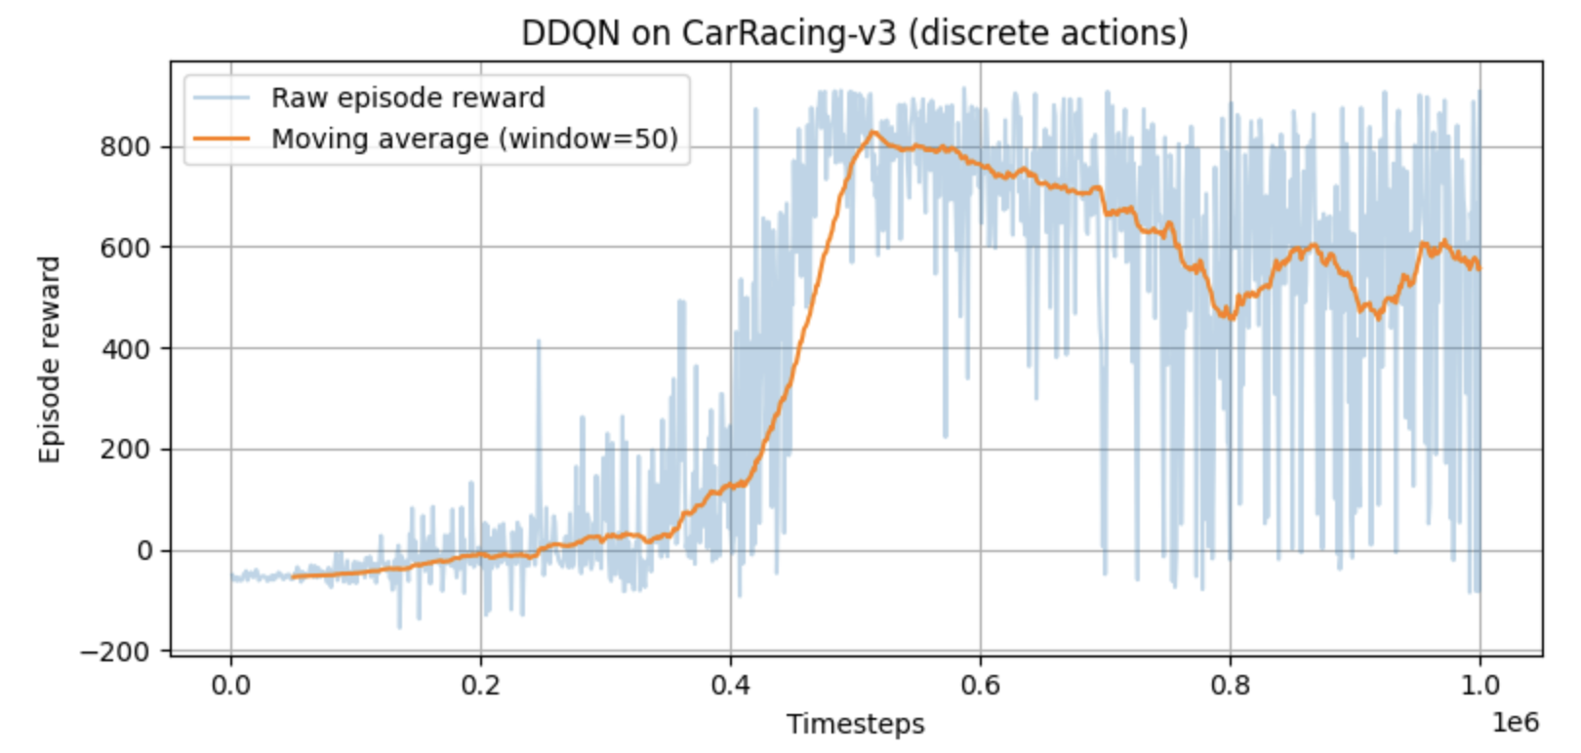
Fig. 3: Episode rewards across 1 million time steps

At 1 million time steps, the following were the returns for each episode. Most of the episodes achieve high returns between 520 to 700. Only one episode performed poorly. There was some variability due to having negative returns in one episode. 9 out of 10 episodes showed strong driving. The episodes that achieved 500 or higher rewards had stable driving. A reward of 700 is very good. However, the policy is not fully stable since there is some instability with one episode having negative rewards.

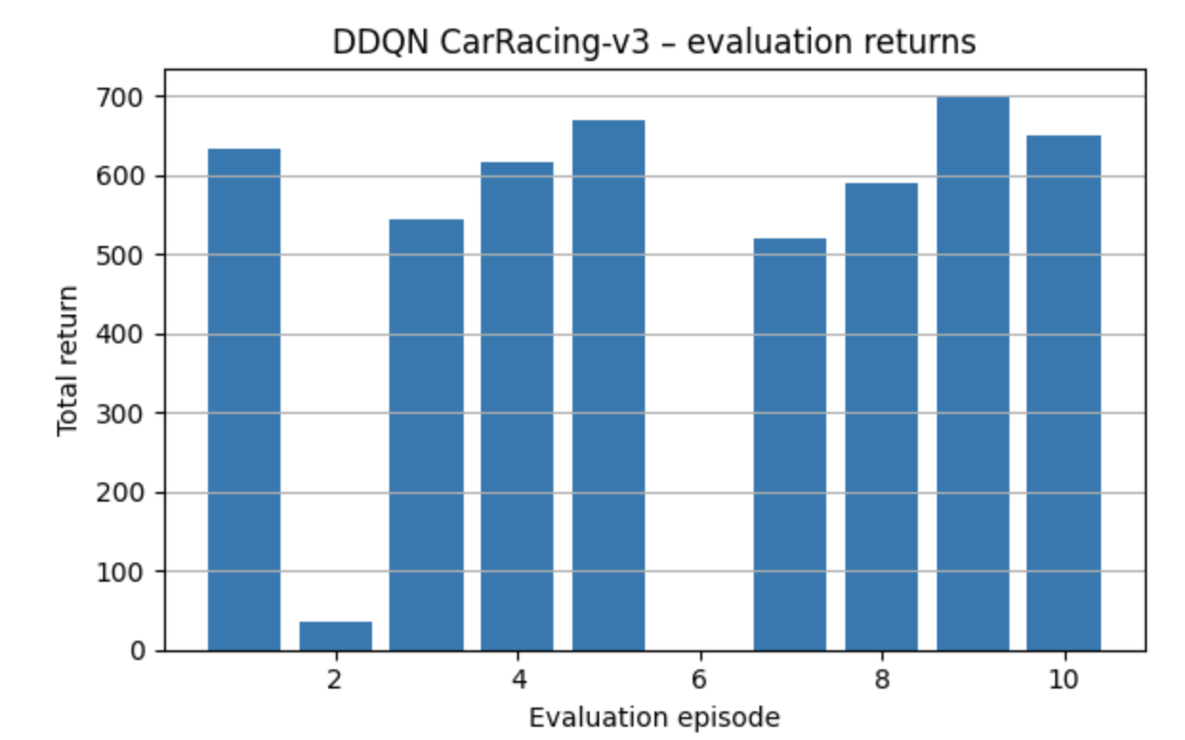
Fig. 4: Total returns in each episode across 1 million time steps

The following video shows how the racecar drives when trained at 1 million steps:
https://drive.google.com/file/d/1qSuZ8zXigcoHw7S2f-qMRvYXs4zQTHIZ/view?usp=drive_link

Time Steps: 600k

At 600,000 time steps, the following were the rewards per timestep. The rewards reach around 800 points at 600,000 time steps. Over 10 episodes, the mean reward is 809.85 ± 147.64. From 0 - 300k time steps, the reward ranged from 0 to -50. There was high noise and inconsistency. At this stage there was random exploration. From 300k - 400k time steps, there is a sharp and steady rise in the moving average. The agent is starting to learn competent driving behavior. From 400k - 600k time steps, the move average peaks around 850-900 rewards. This shows a stable policy, strong generalization to many track segments, and a replay buffer rich with successful experiences.

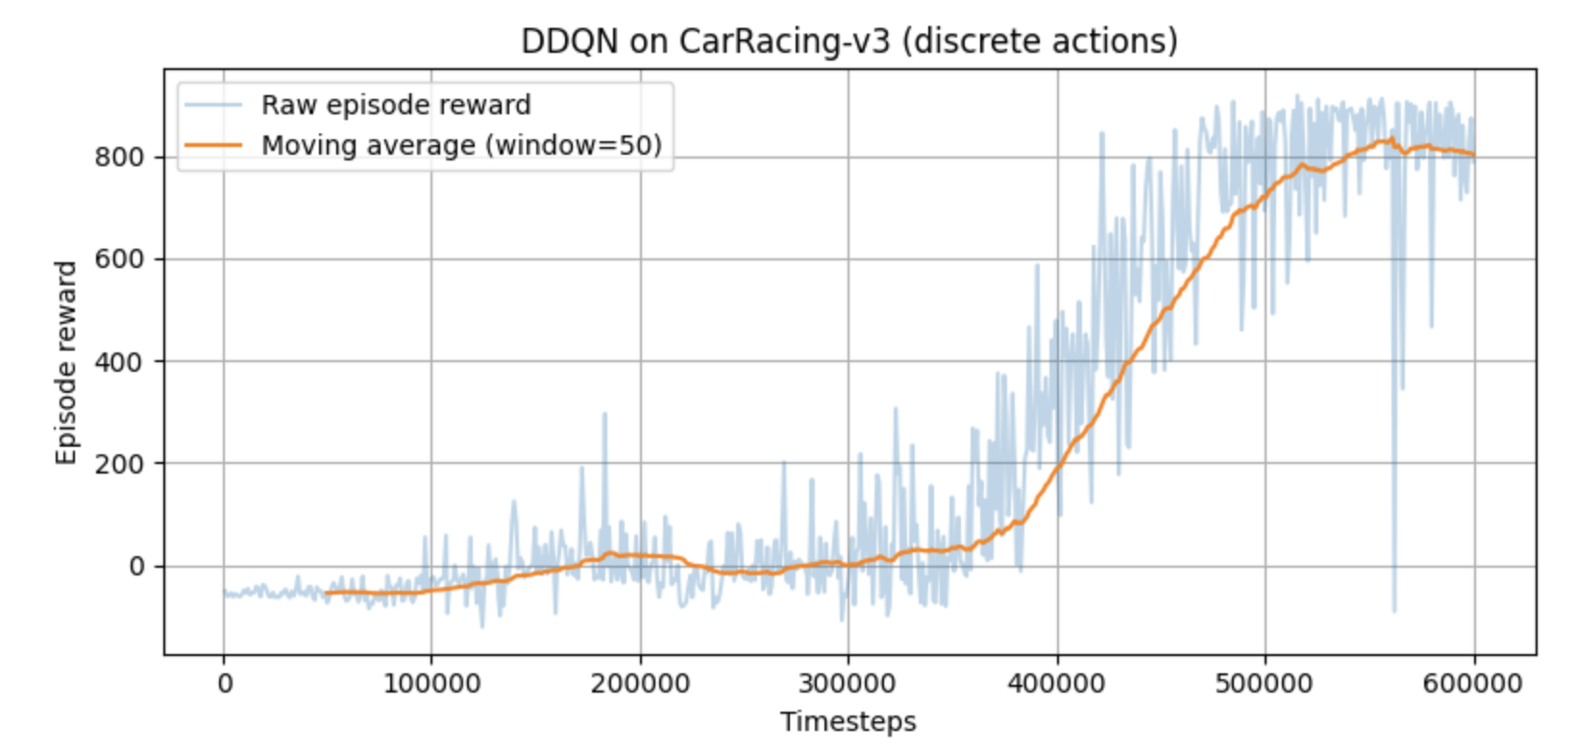
Fig. 5: Episode rewards across 600,000 time steps

At 600k time steps, the following were the returns for each episode. In 7 out of 10 episodes, the total returns are above 800. A few episodes fall in the range of 450 - 550. Only one episode performs poorly, with around 250 rewards. Overall, the agent performs well.

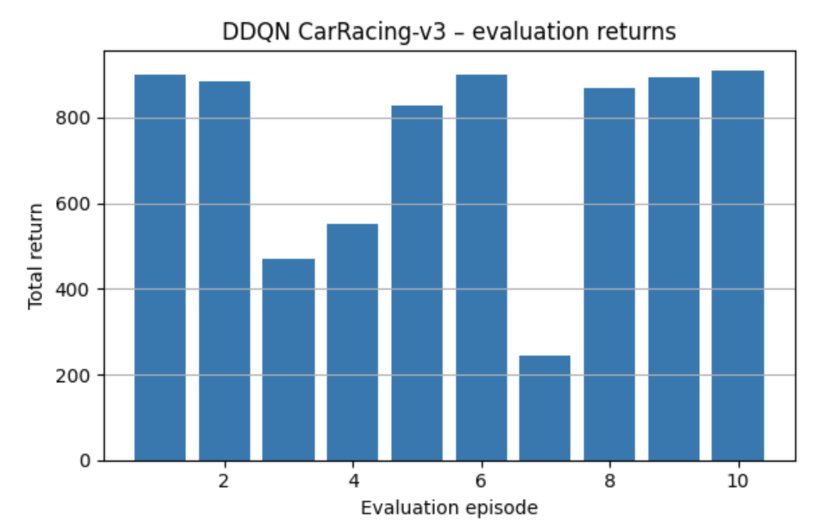
Fig. 6: Total returns in each episode across 600,000 time steps

The following video shows how the racecar drives when trained at 600,000 steps:
https://drive.google.com/file/d/1vcCzmlOQdQLesd7R8Zr7Ttv1w6WTPe1u/view?usp=drive_link

PPO
When training our PPO agent, we also used a CNN-based policy. After converting frames to grayscale, we stacked every four consecutive frames, so the agent could learn the direction that the car travels in relation to the track. Training for one million steps took roughly five hours on an A-100 GPU. The mean reward for the best model was 826.14 +/- 208.54. Although the reward oscillates, it increases overall until its peak at 850, 000 time steps. Though the mean reward is high, the model does show significant variance.

Model type : PPO
Discrete: No
Average reward: 826.14 +/- 208.54
Training Time: 4:20:56
Total training steps: 1e6

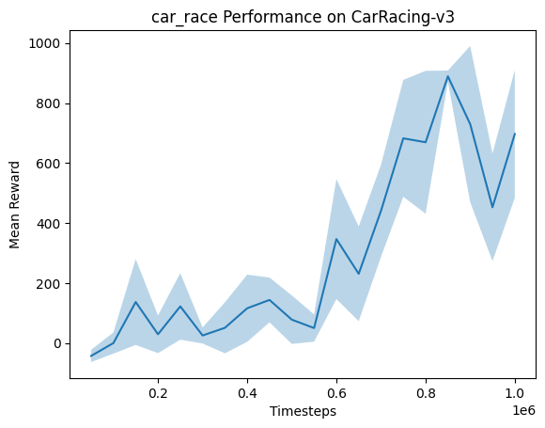
Code and video:
https://drive.google.com/drive/folders/1lXt_bshPiNpw0CaxXSyHVUW5u_TZb-qU?usp=drive_link
The video
SAC

SAC Smoke test with 20k: SAC with a CNN policy is up and running: a smoke test was performed at 20k steps. Next, we'll train SAC much longer (about 1-3 million steps) and save the best model along the way. For DDQN, we'll use a different set of discrete actions (a grid of steer and throttle options) with finer controls and evaluate on the same seeds. We trained SAC on CarRacing-v3 for only ~20k steps with 4 parallel environments and 4-frame stacking, then ran deterministic evaluations with a cap of 3000 steps. (The environment itself times out around 1000). Across five test seeds, every run hit the 1000-step time limit. This is normal for such a short training run and shows the pipeline works. We saved a short video-one episode-and a simple bar chart of rewards to our shared folder.

Colab Link : https://colab.research.google.com/drive/1L6fDZZgxpz3yptoyTeYaajuWkbQZfIWN

Smoke test on 20K:

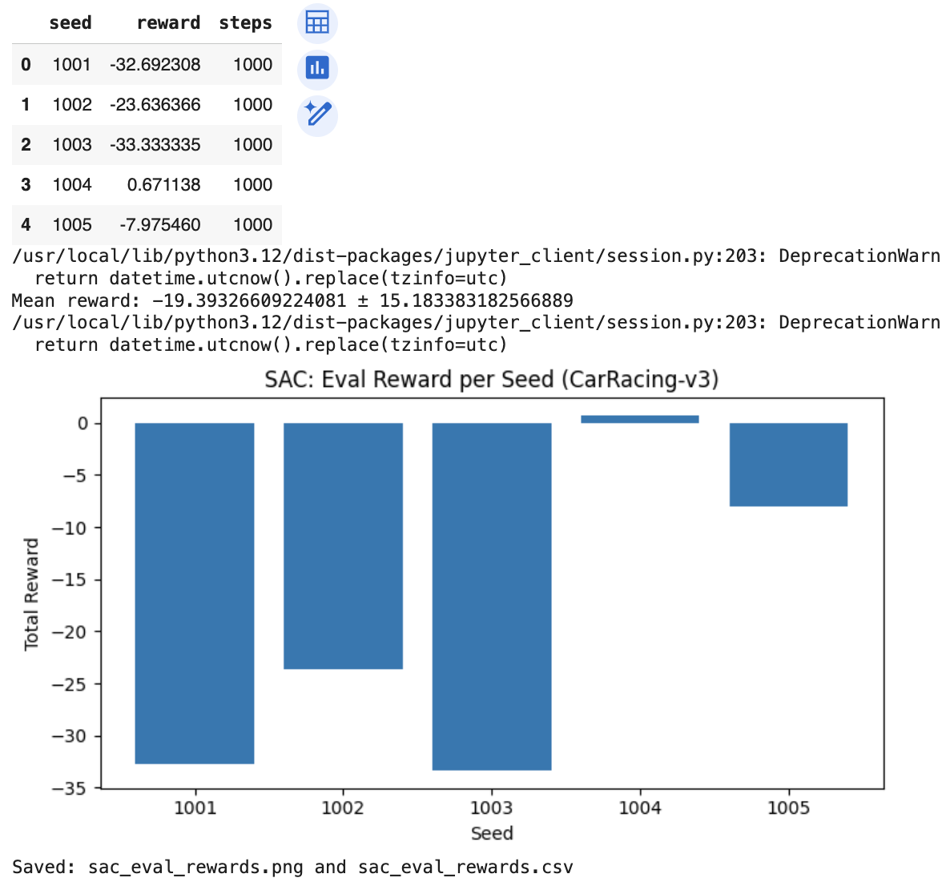

We train a Soft Actor-Critic (SAC) agent on the Gymnasium CarRacing-v3 environment with a continuous action space: steering, throttle, and brake. The agent learns directly from pixels, which requires converting frames to 84×84 grayscale, stacking 4 consecutive frames for motion capture, and normalizing rewards during training for more stabilized learning. We use Stable-Baselines3 with a CNN-based policy and slightly larger feature extractor for image inputs, and all experiments were run on Google Colab with an A100 GPU. We follow a staged process in training: firstly, a small 20k-step smoke test to make sure the whole pipeline (data flow, logging, evaluation, and video export) works correctly; secondly, we tried a 1M-step run, but it became too slow and unstable over roughly 12 hours of training, so we stopped it and instead focused on a 500k-step run.
Because performance can improve and then later degrade in reinforcement learning, in this last 500k-step experiment we periodically evaluated the agent and saved the best checkpoint based on the evaluation performance. The best checkpoint reached an average reward of 682.02 ± 268.29 over multiple evaluation episodes; this means that the car can usually follow the track for long stretches but still shows high variability between episodes and tracks. Interestingly, the final model at the very end of training performed worse than this best checkpoint, reinforcing the need for model selection based on validation performance rather than just using the last weights. The total training time for this 500k-step run was 7 hours, 26 minutes, and 35 seconds on the Colab A100. Overall, SAC worked well for this continuous-control, pixel-based task, especially with frame stacking and reward normalization, but the results also highlight that pixel-based RL is sample-hungry and high-variance. With more time and resources, we would extend training to at least 1M steps, add early stopping when evaluation performance stops improving, and run multiple seeds in order to get a more reliable estimate of performance.
Experimentation includes: Experimented with 20k as smoke test, gave some results and proceeded with 1M didn’t work for 12 hrs and stopped, so switched to 500k, converged and got the graph.
Model type : SAC
Discrete: No
Average reward: 682.02 ± 268.29
Training Time: 7:26:35
Total training steps: 500k
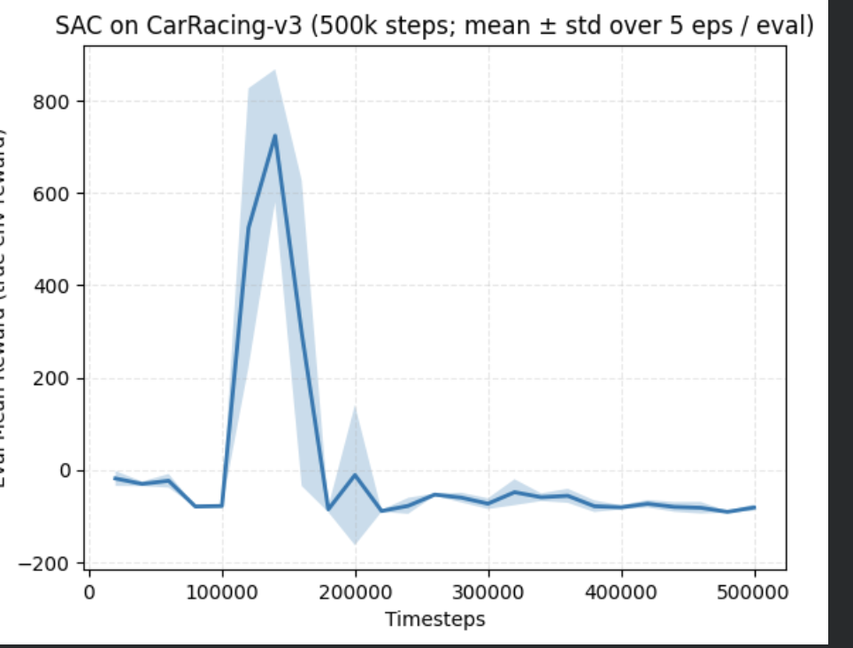
Link : Includes videos, code, plots.
https://drive.google.com/drive/u/0/folders/1mjBbcDILNuhVLBodaazJ5ZBymi427Ond
A brief conclusion
Overall, this project has shown that deep reinforcement learning can indeed learn autonomous racing behavior in a challenging, pixel-based environment but that performance and stability depend strongly on the choice of algorithm and the training setup. DDQN, PPO, and SAC all managed to learn meaningful driving policies in the 2D CarRacing-v3 environment. However, DDQN benefited from having a discretized action space; PPO reached high average rewards with frame stacking, while SAC was very capable of continuous control but showed higher variance and sensitivity to training time. Working with a 3D PyBullet-based racing environment highlighted more practical constraints because it was harder to run reliably on the available hardware; thus, the stable 2D setup with Stable-Baselines3 became the main focus of this thesis. Taken together, the results indicate that value-based methods such as DDQN can be competitive if the action space is carefully discretized, PPO offers a good tradeoff between performance and stability, and SAC is a promising approach for continuous control but requires more careful tuning and model selection, especially when learning directly from images.
In our experiments on the 2D CarRacing‑v3 environment, all three algorithms learned non‑trivial driving policies, but with different performance profiles. DDQN reached its best performance around 600k timesteps, with an average episode return of about 809.85 ± 147.64 over 10 evaluation episodes, indicating mostly stable driving with occasional failures. PPO, trained for 1M timesteps with a CNN policy and frame stacking, achieved the highest mean return at 826.14 ± 208.54, but with noticeably higher variance across episodes. SAC, trained for 500k timesteps with continuous actions and reward normalization, obtained a best‑checkpoint performance of 682.02 ± 268.29, showing that it can follow the track for long stretches but with substantial run‑to‑run variability. Overall, PPO gave the highest average reward, DDQN was competitive and more consistent once converged, and SAC showed promise for continuous control but was the most sensitive to training length and randomness.
Contribution Sections
Sravani worked on SAC algorithm with 20k, 1M, 500k , successful with 20k, 100k and 500k steps with mean reward. She did research work in finding suitable algorithms, trying to run race car using the 3D environment of gymnasium explicitly. Considered baselines like stable-baselines3 would be suitable along with team by comparing with OpenAI gym.
Sonal worked on the DDQN algorithm with 25k, 1M, and 600k time steps. She found that the model converged at 600k timesteps from the 1M model training. Multiple research papers utilized DQN for the same car racing problem, but she went with DDQN because it’s superior to DQN due to handling some of the overestimation issues from DQN. Sonal worked with stable-baselines3.
Anoushka worked on the PPO algorithm with 500k and 1 million time steps. She experimented with different levels of stacking to improve performance. She also got the 3D environment working locally on cpu, though she decided not to use it because it was still incompatible with the colab gpu and she did not have access to HPC. She also trained a recurrent PPO agent with cnnLSTM, but found that performance was very low.
A list of references in properly formatted IEEE style
[1] K. Güçkıran and B. Bolat, "Autonomous Car Racing in Simulation Environment Using Deep Reinforcement Learning," 2019 Innovations in Intelligent Systems and Applications Conference (ASYU), Izmir, Turkey, 2019, pp. 1-6, doi: 10.1109/ASYU48272.2019.8946332.
[2] I. G. B. Petrazzini and E. A. Antonelo, "Proximal Policy Optimization with Continuous Bounded Action Space via the Beta Distribution," 2021 IEEE Symposium Series on Computational Intelligence (SSCI), Orlando, FL, USA, 2021, pp. 1-8, doi: 10.1109/SSCI50451.2021.9660123.
[3] Yuwono, F., Gan Pang Yen & Jason Christopher. Self-Driving Car Racing: Application of Deep Reinforcement Learning. arXiv:2410.22766 [cs.AI] (2024)
[4] Li, Changmao. Challenging On Car Racing Problem from OpenAI gym. arXiv:1911.04868 [cs.AI] (2019).
[5] Maniyar, Yash & Nidhi Manoj. Racetrack Navigation on OpenAIGym with Deep Reinforcement Learning. Stanford University AA228/CS238 final project report (2019). Available as PDF: https://web.stanford.edu/class/aa228/reports/2019/final9.pdf

